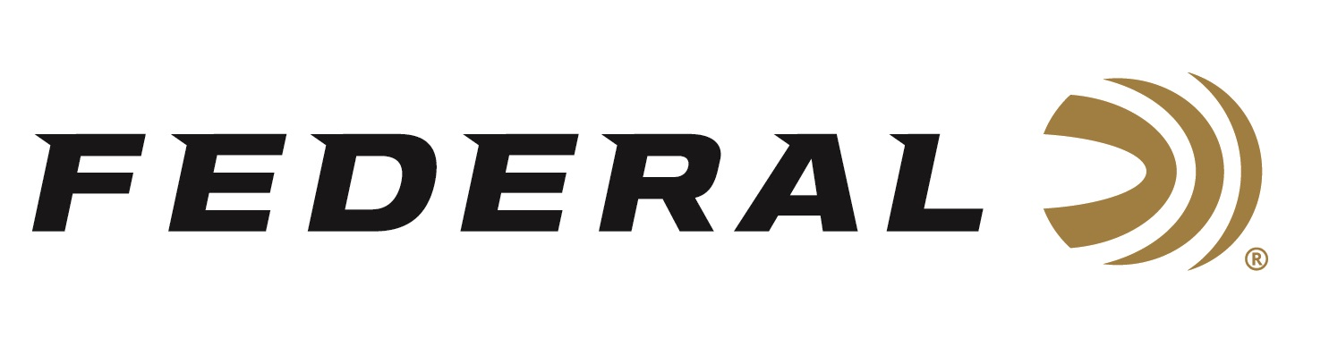

FOR IMMEDIATE RELEASE

Federal Ammunition Raises an Astonishing $218,000 for Local Organizations

ANOKA, Minnesota – June 20, 2022 – In celebration of Federal’s 100th Anniversary, Federal will be donating more than $218,000 dollars to local organizations in support of their critical missions. Funds for these donations resulted from silent and live auctions that occurred during a company event on June 18, 2022, celebrating the anniversary milestone with current and retired employees and their families, industry friends, and local dignitaries.

“Industry partners stepped up and generously donated to the auctions in support of a key element in Federal’s mission statement and its legacy of giving back and supporting the local communities where our employees live and work,” stated Federal Ammunition’s President Jason Vanderbrink. “To see that amount of money raised, that is what it was all about, helping out the community! Long after we are gone, the legacy of helping the community will stay part of Federal’s DNA. Thank you to the employees, retirees, and guests for the generosity, it is simply tremendous,” says Vanderbrink.

The three organizations benefiting from the auctions and other generous donations are the Anoka Police Department, Feed My Starving Children, and the Anoka County Brotherhood Council.

Anoka Police Department- established in 1878 with a mission to maintain the peace and protection of the public through diligent enforcement of all laws and to effectively respond to calls for service. Dollars contributed will help build a new gun range for critical training.
Feed My Starving Children- as a Christian nonprofit, FMSC is dedicated to seeing every child whole in body and spirit. The FMSC process is simple. Donations given by people just like you fund the meal ingredients. Volunteers hand-pack the meals. Meals are donated to FMSC food partners around the world, where kids are fed, and lives are saved. According to FMSC, this will provide food to more than 400,000 kids in need.
Anoka County Brotherhood Council- a local food shelf helping those in need of food, clothing, and other resources. Founded in 1971 by four women who wanted to help and did so out of their basements, the organization has grown and alone in 2022 has already served more than 500,000 pounds. According to the Executive Director, this is the largest donation in the charity’s history.

Attending the celebration and accepting the donations were Anoka’s Chief of Police Eric Peterson; Ann Hill, Development Officer at Feed My Starving Children; and Stephanie Lehman, Executive Director at the Anoka County Brotherhood Council. The checks they received did not include an additional surprise auction from Medal of Honor Recipient Sammy Davis, Jr. and proceeds from other sales generously donated from 10K Brewing. Each organization will receive nearly $73,000 dollars to support their organizations and missions.

Press Release Contact: JJ Reich
Senior Communications Manager - Ammunition
E-mail: VistaPressroom@VistaOutdoor.com

About Federal Ammunition
Federal, headquartered in Anoka, MN, is a brand of Vista Outdoor Inc., an outdoor sports and recreation company. From humble beginnings nestled among the lakes and woods of Minnesota, Federal Ammunition has evolved into one of the world's largest producers of sporting ammunition. Beginning in 1922, founding president, Charles L. Horn, paved the way for our success. Today, Federal carries on Horn's vision for quality products and service with the next generation of outdoorsmen and women. We maintain our position as experts in the science of ammunition production. Every day we manufacture products to enhance our customers' shooting experience while partnering with the conservation organizations that protect and support our outdoor heritage. We offer thousands of options in our Federal Premium and Federal® lines-it's what makes us the most complete ammunition company in the business and provides our customers with a choice no matter their pursuit.

###

